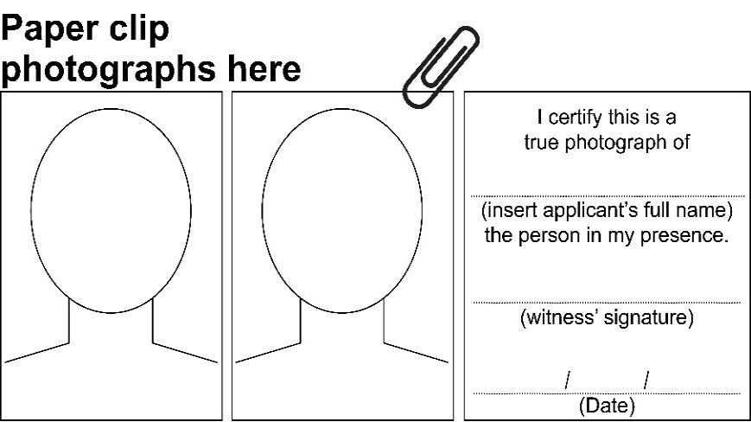
Vision
Impairment
Travel Pass

New application
Please read the following instructions before completing this application.
The Vision Impairment Travel Pass (VITP) entitles eligible pass holders to free travel on all TransLink buses, trains, ferries and trams throughout Queensland. Free travel also applies to TransLink and qconnect urban bus and ferry services in regional Queensland.

Eligibility
All legally blind persons, according to the definition below, irrespective of age, are eligible for the VITP.
Legal permanent blindness, as defined in the Commonwealth social security and veterans’ affairs legislation, requires visual acuity on the Snellen Scale after correction by suitable lenses of less than 6/60 in both eyes, or a field of vision constricted to 10 degrees or less of arc around central fixation in the better eye, irrespective of corrected visual acuity.

Using this pass in other states
The travel pass entitles holders to free travel with participating interstate public transport operators, subject to local regulations. Travel pass holders should check with the state/territory they are visiting for further information.

Replacement passes
If a VITP is lost, stolen or damaged, a replacement card can be requested by contacting TransLink on 13 12 30. Requests for a replacement card require confirmation of the cardholder’s full name, date of birth, postal address and, if relevant, their Services Australia Customer Reference Number (CRN) or Veterans’ Affairs File Number.

Authorised witness
Within this document an authorised witness is defined as one of the following:
- Ophthalmologist, Optometrist or Medical Practitioner
- Police Officer
- Justice of the Peace or Commissioner of Declarations
- Solicitor, Barrister or Judge.

Renewing a pass
If you already have a VITP and it is due to expire, please complete the separate renewal form which can be obtained by calling TransLink on 13 12 30 or via the TransLink website http://www.translink.com.au

How to apply
- Complete Part A – Applicant details (this is a mandatory section).
- Select if you wish to complete Part B (provide your concession card details and signed consent) OR Part C (medical practitioner verification).
- Complete Part D (this is a mandatory section) - attach two colour passport size photographs. Ensure they are signed by an authorised witness.
- Complete Part E (this is a mandatory section).
- Return your completed application form and photographs to:

Vision Impairment Travel Pass
Locked Bag 1414
DANDENONG SOUTH VIC 3164
Important Information
Ensure all relevant sections of your application are completed, as incomplete applications cannot be processed and will be posted back to complete in full.
Please allow at least 15 business days to process your application.
If your application is successful, allow further time for your card to be delivered to you by Australia Post.
The VITP is provided to you free of charge for your use only.
For further information contact:
For more information on the VITP:
• telephone TransLink on 13 12 30
• visit the TransLink website at http://www.translink.com.au
• national relay service TTY and modem 13 36 77
• speech to relay service call 1300 555 727 and then ask for 13 12 30
• interpreter service 13 14 50.

PART A – Applicant details
All applicants must complete this section. It can be completed by either the applicant or the applicant’s guardian/agent.
- Title: (Please tick)
Mr ☐
Mrs ☐
Ms ☐
Miss ☐
Other ☐
2. Family Name (block letters):___________________________________
3. First Name (block letters): _____________________________________
4. Permanent residential address (you must be a permanent resident of Queensland):__________________________________________________________________________________________________________________________________________________________________________________________________________________________________________________________________________________________
5. Postal address (if different to above): _____________________________ ________________________________________________________________________________________________________________________________________________________________________________________________________________________________________________________
6. Date of birth: ______________________________________________
7. Contact number: ___________________________________________
8. Email address:_____________________________________________

PART B – Concession card details
You can complete this section if you are the holder of either a:
- Services Australia Concession Card
- Department of Veterans’ Affairs - Concession Card.
If you do not have either of these cards or do not wish to provide your card details then you must complete Part C – medical practitioner verification.
- Are you the holder of a Services Australia Concession Card? (Please tick)
☐ Yes - please complete details below.
☐ No - continue to Question 2.
Services Australia Customer Reference Number (see back of Pensioner Concession Card, Health Care Card or Commonwealth Seniors Health Card):________________________________________________________
Date of Expiry: _________________________________________________

- Are you the holder of a Department of Veterans’ Affairs - Concession Card? (Please tick)
☐ Yes - (please complete details below)
☐ No - Continue to Question 3 Customer Consent
Department of Veterans’ Affairs File Number (see Pensioner Concession Card, Commonwealth Seniors Health Card, gold DVA Health Card, Veteran Card (Gold or White), or DVA Health Pharmaceutical Benefits Card (Orange) (for example QX222987): ____________________________________________________________
Date of Expiry: ________________________________________________

- Customer consent - to be completed by the applicant or guardian.
This consent will be used for the sole purpose of authorising Services Australia to provide information to the Department of Transport and Main Roads (TMR) and their external contractors to assess your eligibility in relation to concessions or services provided by TMR.

Customer confirmation
I, ________________________ (insert name) authorise
- TMR and/or their contracted travel pass administrators to use the Services Australia Confirmation eServices to perform a Centrelink/DVA enquiry of my Centrelink or Department of Veterans’ Affairs customer details and concession card status in order to enable the business to determine if I qualify for a concession, rebate or service.
- Services Australia to provide the results of that enquiry to TMR or their contracted travel pass administrator.
I understand that:
- TMR or their external contractors will use information I have provided to confirm my eligibility for a VITP and will disclose personal information including my name, address, payment and concession card type and status.
- this consent, once signed, remains valid while I am a customer of TMR unless I withdraw it by contacting TMR or Services Australia.
- I can obtain proof of my circumstances/details from Services Australia and provide it to the external contractors so that my eligibility for VITP can be determined.
- if I withdraw my consent or do not alternatively provide proof of my circumstances/details, I may not be eligible for the VITP provided by TMR.
- Do you give consent for the status of your Commonwealth Benefit to be confirmed? (Please tick)
☐ Yes
☐ No
If you do not give consent to verify your eligibility you are REQUIRED to obtain a photocopy of both sides of your Services Australia (Centrelink) Concession Card or Department of Veterans’ Affairs Concession Card and have the photocopy certified as a true and correct copy by an authorised witness.
A brochure is available from Services Australia that provides more details about the Centrelink Confirmation eServices or on the Services Australia website at https://www.servicesaustralia.gov.au/individuals/centrelink
Please sign and date below to verify that you have read and understand the above information.
NB: If you are completing this form electronically then once the form is complete, print out a copy then sign and date the following declaration.
Signature: __________________________________________
Date: _______________________________________

PART C - Medical practitioner verification

This section is completed by a Medical Practitioner (only if you are NOT the holder of a Services Australia Concession Card or Department of Veterans’ Affairs - Concession Card or you choose not to provide your concession card details).
Only an Ophthalmologist, Optometrist or Medical Practitioner (Medical Professional) can complete this section. If your Medical Professional concludes that you are legally blind, they must declare, sign and date Part C.
*The definition of legal blindness requires visual acuity on the Snellen Scale after correction by suitable lenses of less than 6/60 in both eyes; OR a field of vision constricted to 10 degrees or less of arc around central fixation in the better eye irrespective of corrected visual acuity.

Uncorrected |  | Corrected |  | Comments:
Right | Left | Right | Left

Visual Field |  | Comments:
Right | Left
Name of Ophthalmologist, Optometrist or Medical Practitioner:___________________________________________________
Address: _____________________________________________________
Contact Number: ______________________________________________

Declaration by Health Professional/General Practitioner or Specialist
I declare that the information provided in this application is complete, true and correct in every detail. I understand TMR is collecting the information on this form to enable assessment of the eligibility of the applicant for membership of the VITP Scheme.
I certify that I have examined ________________________, an applicant for a VITP and find that his/her visual acuity and/or visual field is as above.
As such, does this application meet the requirements for legal blindness*? (Please tick)
☐ Yes
☐ No
Name: _______________________________________________
Signature: ____________________________________________
Date: ________________________________________________

NB: If the applicant does not meet the eligibility for legal blindness, please return this application form to the applicant and kindly advise them that they do not meet the eligibility requirements for legal blindness as stated in the Social Security Act 1991.

PART D - Photographs
Supplying a photograph is mandatory for all applicants. You will need to supply two colour passport sized photographs. Please attach these photographs to the front of this form with paperclips.
Conventional or digital photography and printing methods will be accepted provided photographs are printed without visible pixels or dot patterns and they have not been manipulated, for example, by removing spots or softening wrinkles.
Photographs must:
- be no more than six months old
- be passport size, which is 45-50mm high and 35-40mm wide
- be in colour, printed on photo-quality paper using a high resolution
- have a plain, light coloured background
- show the applicant’s head and top of shoulders
- show the applicant looking directly at the camera, head not tilted in any direction with a neutral expression
- show the applicant with their hat and sunglasses removed.

You will need to get the reverse side of one photograph signed and dated by an authorised witness. An authorised witness is any of the following:
- Ophthalmologist, Optometrist or Medical Practitioner
- Police Officer
- Justice of the Peace or Commissioner of Declarations
- Solicitor, Barrister or Judge.

The authorised witness is required to certify and write the following words on the back of one photograph:
I certify this is a true photograph of (insert applicant’s full name) the person in my presence.
(Witness signature) (Date)

Declaration by witness of photograph
The witness must be satisfied that the photographs represent the applicant’s true identity before completing the below section.
I declare that I meet the requirements to make this declaration. I am satisfied the photograph witnessed by myself represents the applicant’s true identity.
Tick one box:
☐ Medical Practitioner
☐ Police Officer
☐ Justice of the Peace or Commissioner of Declarations
☐ Solicitor, Barrister or Judge.

Witness’ full name: ________________________________________
Witness’ signature: ________________________________________
Date: ___________________________________________________

PART E – Privacy notice and declarations
The declaration must be completed by either the applicant or the applicant’s guardian/agent.

Privacy Notice
TMR is collecting the information on this form for the purposes of administering and assessing your eligibility for a VITP. The information you provide will be accessed only by authorised officers and TMR’s contracted travel pass administrators.
Your personal information will not be disclosed to any other third party without your consent unless required or authorised to do so by law.
Personal information includes such items as name, contact details and address. Any personal information and data collected through the application process will be held in confidence, stored securely and only used by TMR and our external contracted travel pass administrators for the purposes of administering cards.

Declaration
Note: If you are completing this form electronically, please print the form then sign and date the following declaration.
I certify the details provided by me are true and correct. I authorise TMR, or their external contractors, to make reasonable enquiries to verify any details provided in this application, including with my medical practitioner if required. I accept the VITP Privacy Notice.
I accept the Vision Impairment Travel Pass Terms and Conditions
Applicant’s declaration (must be 16 years and over)

Signature: __________________________________________
Date: __________________________________________

Please note: If the applicant is under 16 years of age, or is unable to sign the application, the applicant’s guardian or agent must complete and sign the section below.
Guardian/Agent declaration
I declare that I have read and explained the contents of this application to the applicant, and that the details of the applicant set out in this application are correct. I declare that the applicant has authorised TMR, or their external contractors, to make reasonable enquiries to verify any details provided in this application, including with their medical practitioner if required. I declare that I have read and explained the VITP Privacy Notice to the applicant and the applicant has accepted this notice.
I declare that I have read and explained the Vision Impairment Travel Pass Terms and Conditions to the applicant and the applicant has accepted these Terms and Conditions.
Guardian/Agent name (and relationship to the applicant):_____________________________________________________

Guardian Agent phone number: ____________________________________
Signature: ____________________________________________________
Date: ________________________________________________________

Vision Impairment Travel Pass Application Checklist
Please check this list to ensure that all the required information is supplied with the application form.
You must complete Part A of application form (page 4)
☐ Completed by applicant or guardian/agent.
Either Part B of application form (page 5)
☐ Completed by applicant
☐ Centrelink customer reference number provided
or
☐ Department of Veterans’ Affairs file number provided
☐ Signed and dated by applicant.
Or Part C of application form (if required) (page 8)
☐ Completed by health professional
☐ Signed and dated by health professional.
Part D - Photographs (page 10)
☐ Two current passport-sized photographs supplied
☐ One passport sized photograph signed and declared by witness
☐ Declaration by witness of photograph completed.
You must complete Part E of application form (page 12)
☐ Completed by applicant or guardian/agent
☐ Signed and dated by applicant or guardian/agent.
Please post the application, photographs and attachments to:
Vision Impairment Travel Pass
Locked Bag 1414
DANDENONG SOUTH VIC 3164

Office Use Only
Vision Impairment Travel Pass Approved
☐ No ► please complete comments below.

Comments:
__________________________________________________________________________________________________________________
__________________________________________________________________________________________________________________
☐ Yes ► Issue date: / / Expiry date: / /

Travel Pass Number: _________________________
Approved by: _______________________________
Refused by: ________________________________

