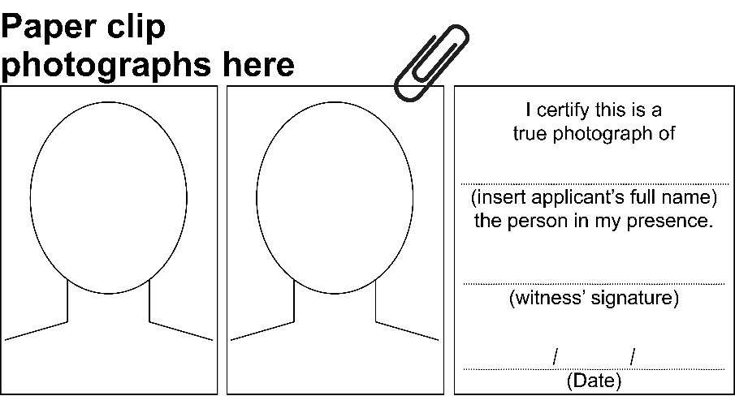
Vision Impairment Travel Pass - Renewal

Complete this form if you currently hold a Vision Impairment Travel Pass (VITP) which is due to expire soon. Your expiry date is printed on your card.
If you are applying for a Vision Impairment Travel Pass for the first time, please complete the separate form titled ‘Vision Impairment Travel Pass – Application’. This form can be obtained by calling TransLink on 13 12 30 or via the TransLink website: https://www.translink.com.au/tickets-and-fares/ticket-types/disability/vision-impairment-travel-pass
Passes are valid for 10 years from the date of issue.
Lost, stolen or damaged cards
If your card is lost, stolen or damaged then you can simply request a replacement pass by phoning TransLink on 13 12 30.
Please read the following instructions before completing this application.
Once your VITP expires it can no longer be used to receive free travel on eligible TransLink and qconnect services and with participating interstate public transport operators. You must renew your VITP prior to its expiry date, allowing at least 15 business days to process your card renewal plus time for mail delivery.

How to renew your Vision Impairment Travel Pass
- Complete Parts A and B of this form.
- Provide two colour passport sized photos. An authorised witness must sign a declaration confirming your identity on the reverse side of one photograph.
- Sign the declaration by witness of photograph section confirming details are correct.
- Send the completed form and photographs to:
Vision Impairment Travel Pass
Locked Bag 1414
DANDENONG SOUTH VIC 3164
Once your renewal application is approved, you will be posted a new VITP.

Photographs
For renewal applications, two current colour passport sized photographs of you are required. Please attach these photographs to the front of this form with paperclips.
Conventional or digital photography and printing methods will be accepted provided photographs are printed without visible pixels or dot patterns and they have not been manipulated, for example, by removing spots or softening wrinkles.
Photographs must:
- be no more than six months old
- be passport size, which is 45-50mm high and 35-40mm wide
- be in colour, printed on photo-quality paper using a high resolution
- have a plain, light coloured background
- show the applicant’s head and top of shoulders

- show the applicant with their hat and sunglasses removed.
An authorised witness must state that these photographs represent the applicant’s true identity. An authorised witness is any of the following:
- Ophthalmologist, Optometrist or Medical Practitioner
- Police Officer
- Justice of the Peace or Commissioner of Declarations
- Solicitor, Barrister or Judge.

You will need to get the reverse side of one photograph signed and dated by an authorised witness. The authorised witness is required to certify and write the following words on the back of one photograph:

I certify this is a true photograph of (insert applicant’s full name) the person in my presence.
(Witness signature) (Date)

Declaration by witness of photograph
The witness must be satisfied these photographs represent the applicant’s true identity before completing the below section.
I declare that I meet the requirements to make this declaration. I am satisfied the photograph witnessed by myself represents the applicant’s true identity.
Tick one box:
☐ Medical Practitioner
☐ Police Officer

☐ Justice of the Peace or Commissioner of Declarations
☐ Solicitor, Barrister or Judge.
Witness’ full name: ________________________________________
Witness’ signature: ________________________________________
Date: ________________________________________

PART A – Applicant details
All applicants must complete this section. It can be completed by either the applicant or the applicant’s guardian/agent.
- Customer Reference Number (CRN): ____________________________
(The CRN is a seven-digit number located above the card holder’s name on the VITP (1xxxxxx))
- Title: (Please tick)
Mr ☐
Mrs ☐
Ms ☐
Miss ☐
Other ☐
2. Family Name (block letters):___________________________________
3. First Name (block letters): _____________________________________
4. Permanent residential address (you must be a permanent resident of Queensland):______________________________________________________________________________________________________________________________________________________________________________________________________________________________________________________________________________________________________
5. Postal address (if different to above):______________________________ ________________________________________________________________________________________________________________________________________________________________________________________________________________________________________________________

6. Date of birth: ______________________________________________
7. Contact number: ___________________________________________
8. Email address:_____________________________________________

PART B - Privacy Notice and Declarations
The declaration must be completed by either the applicant or the applicant’s guardian/agent.

Privacy Notice
The Department of Transport and Main Roads (TMR) is collecting information on this form for the purposes of assessing your eligibility for a VITP. The information you provide will be accessed only by authorised officers and the department’s external contractors. Your personal information will not be disclosed to any other third party without your consent unless required or authorised to do so by law.
Personal information includes such items as name, contact details and address. Any personal information and data collected through the application process will be held in confidence, stored securely and only used by TMR and our external contractors for the purposes of administering cards.

Declaration
Please note:
If you are completing this form electronically, please print the form then sign and date the following declaration.
I certify the details provided by me are true and correct. I authorise TMR, or their external contractors, to make reasonable enquiries to verify any details provided in this application. I accept the VITP Privacy Notice.
I accept the Vision Impairment Travel Pass Terms and Conditions.
Applicant’s declaration (must be 16 years and over)
Signature: __________________________________________
Date: ____________________________________________

Please note: If the applicant is under 16 years of age, or is unable to sign the application, the applicant’s guardian or agent must complete and sign the section below.

Guardian / Agent declaration
I declare I have read and explained the contents of this application to the applicant, and the details of the applicant set out in this application are correct. I declare the applicant has authorised TMR, or their contracted travel pass administrator, to make reasonable enquiries to verify any details provided in this application. I declare I have read and explained the VITP Privacy Notice to the applicant and the applicant has accepted this notice.
I declare I have read and explained the Vision Impairment Travel Pass Terms and Conditions to the applicant and that the applicant has accepted these Terms and Conditions.
Guardian/Agent name (and relationship to the applicant):____________________________________________________

Guardian Agent phone number: __________________________________
Signature: ____________________________________________________
Date: ________________________________________________________

Vision Impairment Travel Pass Renewal Checklist
Please check this list to ensure all the required information is supplied with the renewal form.
You must complete the applicant’s details section of the form (page 5 and 6)
☐ Completed by applicant or guardian/agent.

You must complete the declaration part of the form (page 7 and 8)
☐ Signed and dated by applicant or guardian/agent.

Photographs (pages 2 - 4)
☐ Two current passport-sized photographs supplied.
☐ One passport photograph signed and declared by witness.
☐ Declaration by witness of photograph section completed.

Please post the application and photographs to:
Vision Impairment Travel Pass
Locked Bag 1414
DANDENONG SOUTH VIC 3164
Important Information
Ensure all relevant sections of your application are completed, as incomplete applications cannot be processed and will be sent back to be completed.
Please allow at least 15 business days to process your application plus time for mail delivery. The VITP is provided to you free of charge for your use only.

For further information contact:
For more information on the Vision Impairment Travel Pass:
• telephone TransLink on 13 12 30
• visit the TransLink website at http://www.translink.com.au
• national relay service TTY and modem 13 36 77
• speech to relay service call 1300 555 727 and then ask for 13 12 30
• interpreter service 13 14 50

Office Use Only
Vision Impairment Travel Pass Approved
☐ No ► please complete comments below.

Comments:
__________________________________________________________________________________________________________________
__________________________________________________________________________________________________________________
☐ Yes ► Issue date: / / Expiry date: / /

Travel Pass Number: _________________________
Approved by: _______________________________
Refused by: ________________________________

